**Setup Application Gateway & the Internal Front-End Load Balancer for an application**

After you have deployed an application to service fabric you need to add the port for it to the service fabric cluster Front End load balancer and then to the Application Gateway.

1. **Front End load balancer**

The port is the one you have defined in your serviceManifest.xml e.g.

<Resources>

<Endpoints>

<Endpoint Protocol="http" Name="ServiceEndpoint" Type="Input" Port="8702" />

</Endpoints>

</Resources>

</ServiceManifest>

**Create a new Health Probe**

e.g. 8702Probe

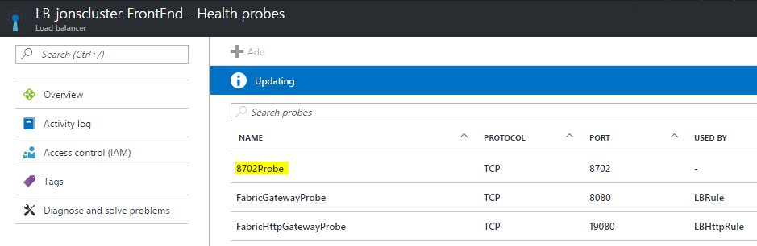

**Create a new Load balancing rule**

e.g. 8702Rule, make sure you set the highlighted items correctly.

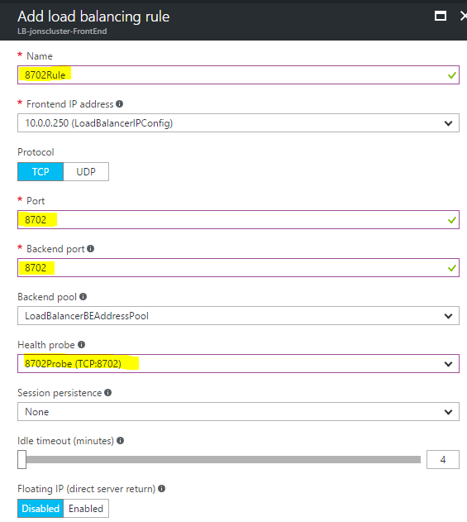

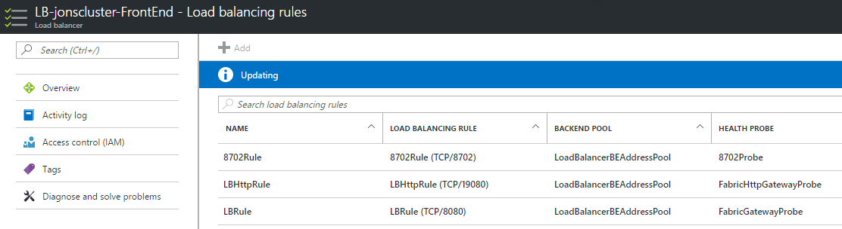

1. **Application Gateway**

**Add a new Health Probe**

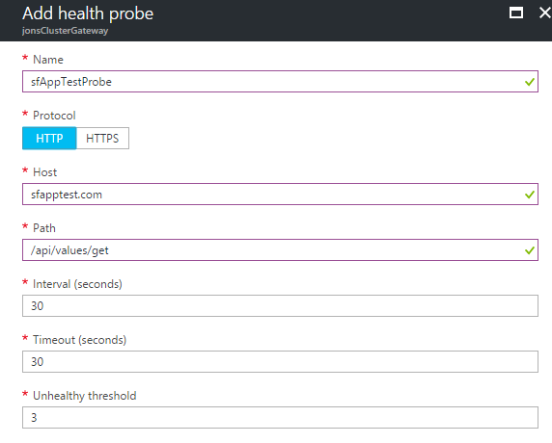

The path just needs to be an endpoint which can return a response so the health probe knows if the application is alive.

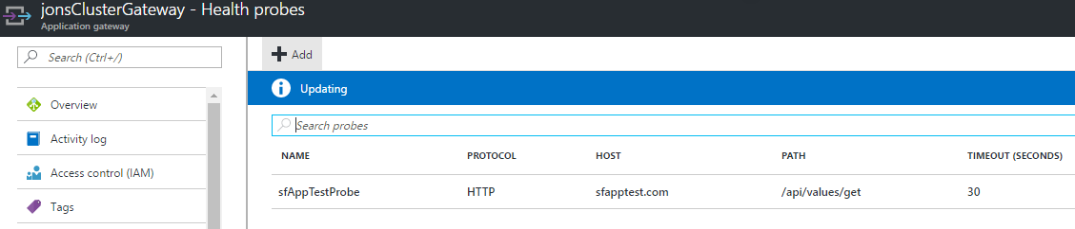

**Add a new Http Setting**

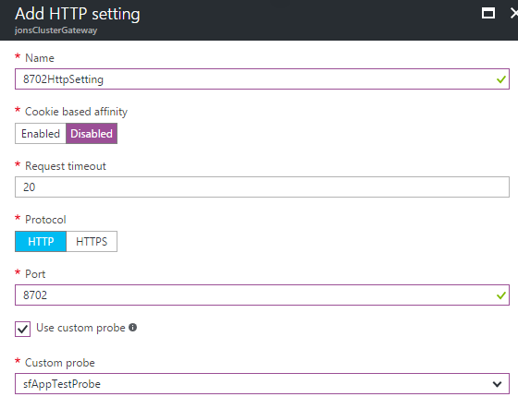

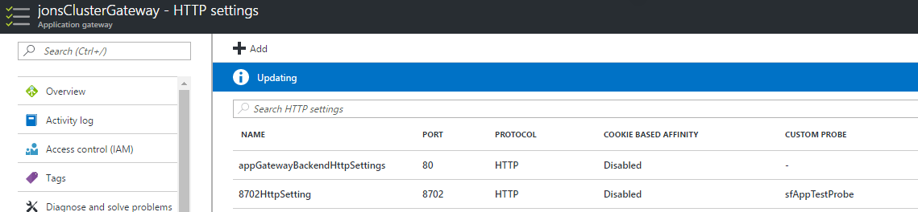

**Add a new Mult-Site Listener**

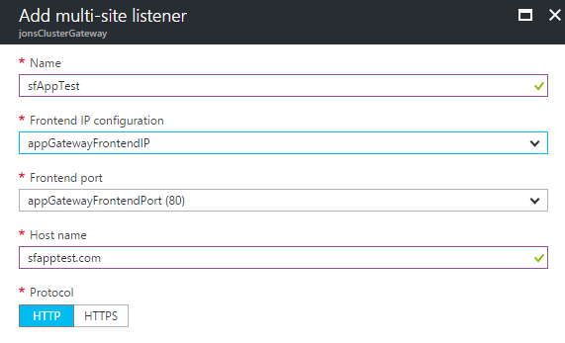

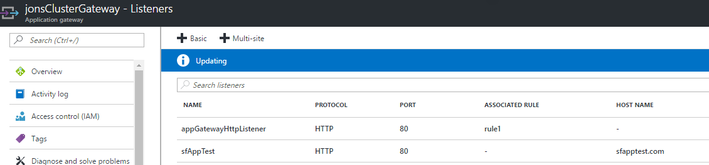

**Add a new Basic rule**

Make sure you choose the httpSetting you created earlier

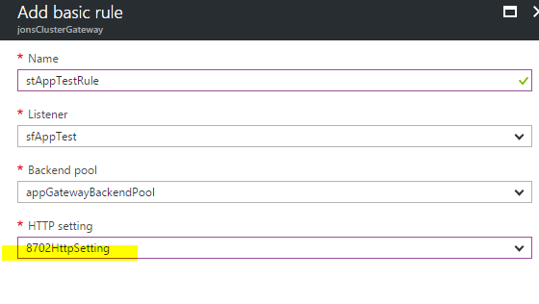

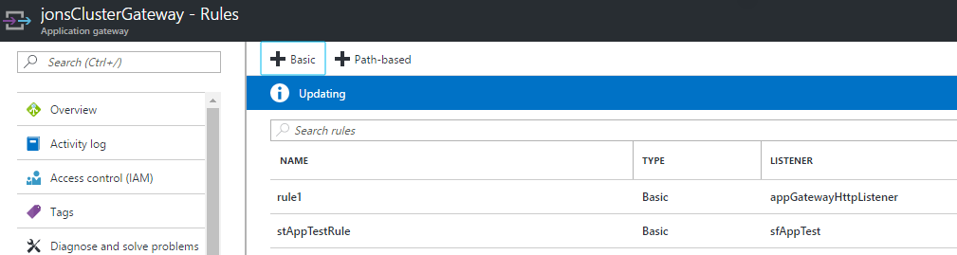

**Remove rule1 for the appGatewayHttpListener**

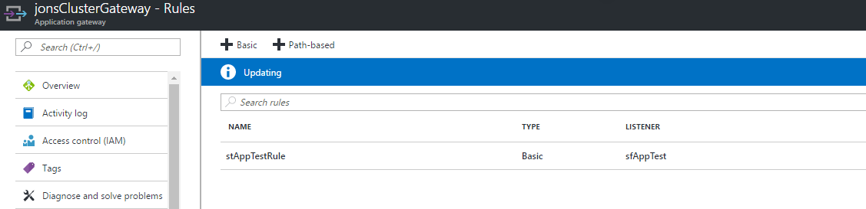

**Check the backend health**

Before connecting via a browser it’s worth checking that the Backend health report is Healthy otherwise you have missed something.

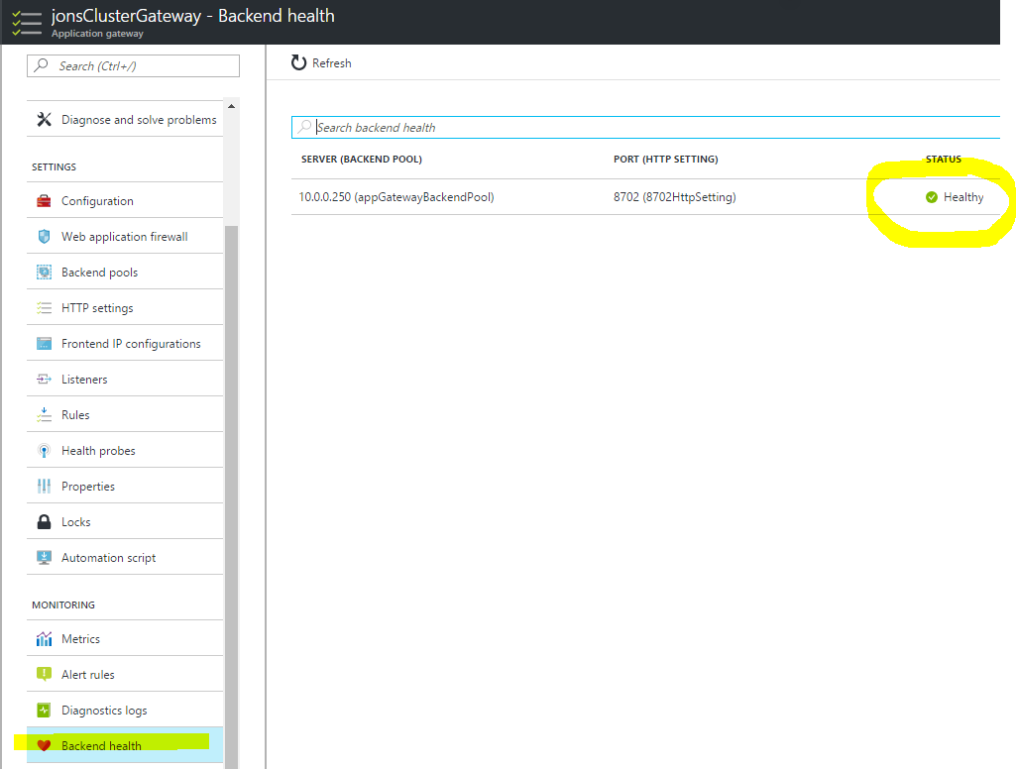

If it’s healthy, try opening your application in a browser e.g.

http://sfapptest.com/api/values/get